SurveyOn

Take Survey

Requirements and Design document

**CONTENTS**

1. Overview 3

2. Site Map 4

3. Page Design 5-7

4. ER Diagram 8

5. Future Enhancements 8

6. References 8

**Requirements and Design Document**

**1. Project Overview**

SurveyOn is a web application for users to take surveys for various categories that are being conducted all over the world. A new user must sign up to the web application to view the various surveys that are taking place and also respond to those surveys they are interested in. Our target market is for any customer -who want to rate the product they are using. This would help a new user who wanted to buy it and who are planning to purchase.

This Java web-application follows the MVC pattern in the following specifications:

1. Model - Java beans to implement the business layer of the application. In this project, we have the User, Survey and Connection classes as Java Beans.

2. View – JSP pages to represent the view to the browser. In this project, we have several JSP pages representing each functionality of the User and Admin.

3. Controller- Servlet pages that control the flow of the application. We have UserLoginServlet – to login a returning user and admin and sign up a new user and send an email to the new user, and Surveycontroller – that handles all the functionality of the User and Admin.

Starting with the home page, we have hyperlinks to view the Surveys, Responders, Recommendation and contact us pages. We can also login from the home page if we are a returning user or admin.

We cannot view the surveys until the user is logged in. This means that a new user will be redirected to the sign-up page and the returning user will be redirected to the login page. Once the signup/login is completed, a user can view the surveys and their details and proceed to respond. It must be noted that whenever a user respond the Rewards would increase. Person with highest rewards are active users. On successful participation, reward would increase. Also, user can report a question if felt inappropriate. Appropriate messages will be displayed to the user when the survey is responded.

The Admin has the functions of approving or disapproving the questions reported by the user. The admin can also view all the login details.

**2.Site Map**:

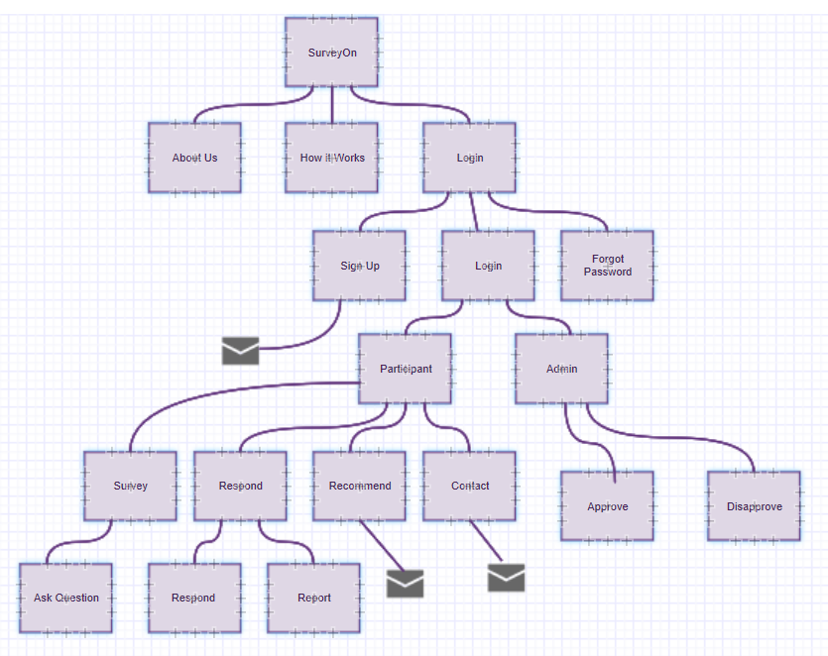

Above is the sitemap for the flow of SurveyOn Application

**3. Page Design**

**3.1 Home Page:**

* **Name:** home.jsp
* **Purpose:** This is the home page of the website. All the basic details of the web application are given here.
* **Audience:** Users, Admin
* **Hyperlinks:** About us, how to work, login

**3.2 Static Pages:**

* **Name:** recommendation.jsp, contact.jsp,about.jsp,how.jsp
* **Purpose:** These pages give info regarding the website and how it works. Also allows to recommend and contact the admin.
* **Audience:** Users, Admin

**3.3 Admin Login page**

* **Name:** admin.jsp
* **Purpose:** This page facilitates admin to login.
* **Audience:** Admin
* **Hyperlinks:** Reported

**3.4 Survey page**

* **Name:** survey,jsp
* **Purpose:** Toview surveys submitted by all the users
* **Audience:** User
* **Hyperlinks:** Add new survey, go to homepage

**3.5 Respond page**

* **Name:** respond,jsp
* **Purpose:** To respond to the surveys submitted
* **Audience:** User
* **Hyperlinks:** Surveys, report history, go to homepage

**3.6 Add Survey**

* **Name:** addsurvey.jsp
* **Purpose:** To add a new survey to the applications
* **Audience:**user

**3.7 Edit Survey page**

* **Name:** editsurvey.jsp
* **Purpose:** To edit a survey in the application
* **Audience:** user
* **Hyperlink:** View survey

**3.8 Report Survey**

* **Name:** report.jsp
* **Purpose:** To report an inappropriate survey the application
* **Audience:** Admin

**3.9 User Login**

* **Name:** login.jsp
* **Purpose:** To facilitate the user to login
* **Audience:** User
* **Hyperlink:** user.jsp

**3.10 Report history Page**

* **Name:** reporth.jsp
* **Purpose:** Lists all thereported surveys
* **Audience:** User
* **Hyperlinks:**go to homepage

**3.11 Recommendations**

* **Name:** recommend.jsp
* **Purpose:** Send email notification to recipients.
* **Audience:** User

**3.12 Contact Us**

* **Name:** contact.jsp
* **Purpose:** Send email notification to recipients.
* **Audience:** User

**3.13 Logout**

* **Name:** logout.jsp
* **Purpose:** logout of the user instance.
* **Audience:** User

**4. ER Diagram:**

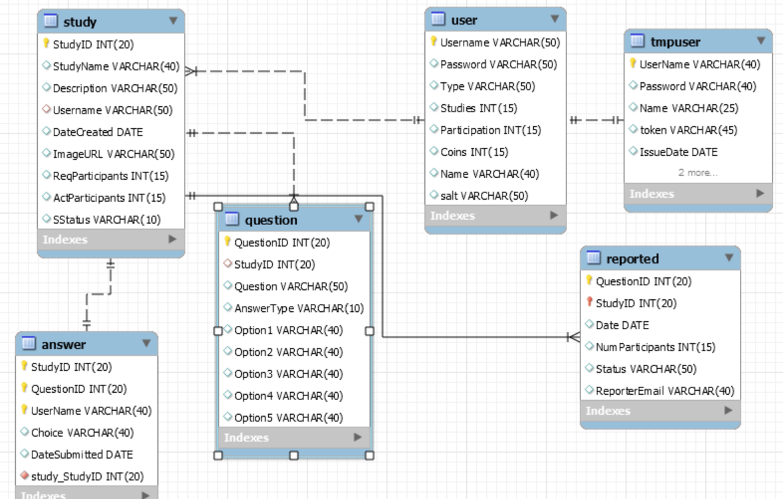

**Entities:**

1. **User**
2. **Admin**

**Attributes:**

**User:**

1. **Username (Primary Key)**
2. **Password**

**Admin:**

1. **AdminUsername (Primary Key)**
2. **AdminPassword**

**5. Future Enhancements**

1. The website can be enhanced by including allowing admin to unsubscribe the invalid uses
2. The website can also be enhanced by adding a video/message chat feature to facilitate users to post live surveys.

**6. References:**

1. https://www.gliffy.com/

2. [www.surveymonkeys.com](http://www.surveymonkeys.com)